Name: Pallab Datta


Replace this text with your Photo
Phone: +91-9474892494

Email ID (Institutional): pd@chest.iiests.ac.in
Email ID (Others, Optional):contactpallab@gmail.com

Resume:
- PhD (IIT, Kharagpur)
- M. S. Pharm (NIPER, Mohali)
- B. Pharm (Pune)
Experience:
  - NIPER Ahmedabad
  - IIEST Shibpur

ORCID: https://orcid.org/0000-0002-7404-4917

SCOPUS: 57201346143 and 36163890900

Google Scholar: https://scholar.google.com/citations?user=_NYJodQAAAAJ&hl=en

Vidwan: 105347
Lab: M. Tech Biomedical Engineering: Biomaterials

Activity: Synthesis and characterization of biomaterials, device design and fabrication by bioprinting, surface coating and nanofiber techniques, biological evaluation, drug delivery.

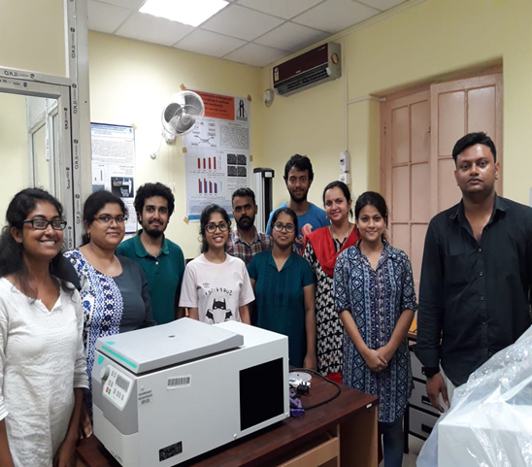
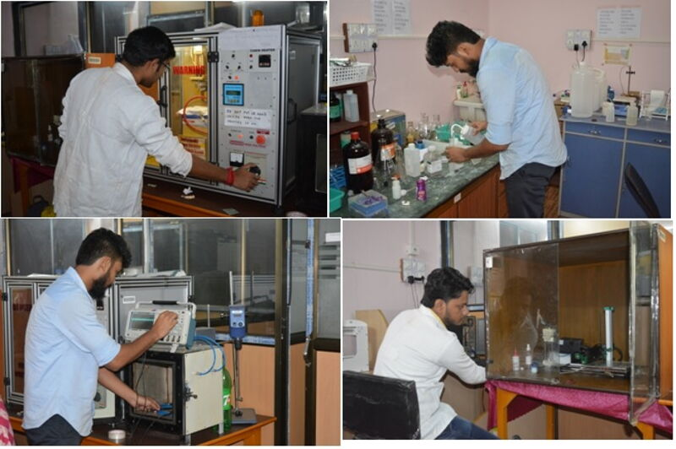
Images:



