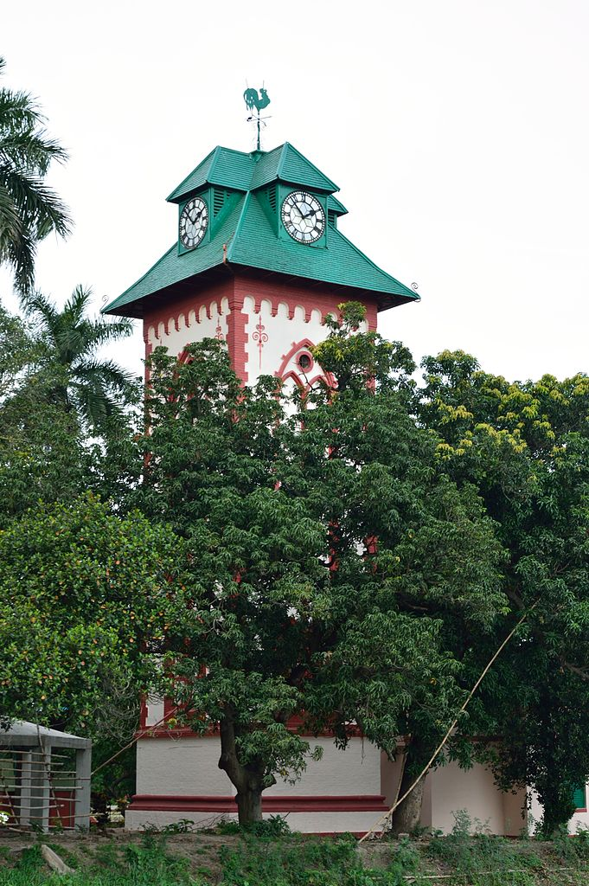INTELLECTUAL PROPERTY MANUAL

**(IPR Cell-IIEST Shibpur)**

IIEST_Shibpur_Logo.tif**(approved in the 19th F.C. and 28th BoG Meetings**

**held on 27.08.2024, effective from 04.10.2024)**



**Indian Institute of Engineering Science and Technology (IIEST), Shibpur**

**Botanic Garden, Howrah**

**Table of Contents**

|  |  |  |
| --- | --- | --- |
| **Sl.** | **DETAILS** | **PAGE** |
| 1 | PREAMBLE | 3 |
| 2 | THE INTELLECTUAL PROPERTY (IP) POLICY | 3 |
| 2.1 | OBJECTIVES OF THE IP POLICY | 3 |
| 2.2 | GUIDELINES | 4 |
| 2.3 | SCOPE OF IP POLICY | 4 |
| 3 | INTELLECTUAL PROPERTY OWNERSHIP | 4 |
| 3.1 | IP FOR INVENTIONS – PATENTS AND DESIGNS | 4 |
| 3.1.1 | OUTCOME OF IN-HOUSE RESEARCH | 4 |
| 3.1.2 | OUTCOME OF SPONSORED / COLLABORATIVE RESEARCH | 5 |
| 3.2 | COPYRIGHT | 5 |
| 4 | REGISTRATION OF PATENTS / COPYRIGHTS / OTHER FORMS OF IP | 6 |
| 4.1 | FILING APPLICATION IN INDIA | 6 |
| 4.2 | FILING OF APPLICATION IN FOREIGN COUNTRIES | 7 |
| 5 | IP CONFIDENTIALITY | 7 |
| 6 | IP MAINTENANCE | 7 |
| 7 | IP COMMERCIALIZATION | 8 |
| 8 | REVENUE SHARING | 8 |
| 9 | DISCLOSURES, CONFIDENTIALITY AND ASSIGNMENT OF RIGHTS | 9 |
| 10 | AGREEMENTS | 9 |
| 11 | CONFLICT OF INTEREST | 9 |
| 12 | JURISDICTION AND DISPUTE RESOLUTION | 10 |
| 13 | EARNEST PATENT FILING DEPOSIT (EPFD) | 10 |
| 14 | DEFINITIONS | 10 |
| 15 | FINANCIAL STRUCTURE FOR IPR CELL, IIEST, SHIBPUR | 11 |
| 16 | IIEST-IPR-Forms | 11-17 |
| 17 | STEPWISE PATENT FILING THROUGH IPR CELL | 18 |

**INTELLECTUAL PROPERTY MANUAL**

## PREAMBLE

With a distinguished history of 168 years, the institution has evolved from its origin as Bengal Engineering College to its current designation as the Indian Institute of Engineering Science & Technology, Shibpur (hereafter referred to as the Institute or IIEST, Shibpur or IIESTS). Throughout its evolution, the Institute has consistently demonstrated a commitment to advancing technical expertise and making substantial contributions to national development. Our mission remains to uphold our status as a leading centre for education, research, and outreach in engineering and technology, driven by a relentless pursuit of excellence across all domains.

In light of the rapid advancements in modern science and technology, , the necessity for a centralized policy governing the creation, protection, and commercialization of intellectual property at IIESTS has become increasingly apparent. To address this need, the Institute has established its Intellectual Property Rights (IPR) Cell. This initiative is designed to promote innovation and safeguard intellectual property within our academic community.

Intellectual property is pivotal in enhancing an organization's competitive edge. In today’s environment, intangible assets—such as knowledge, inventions, brands, designs, and creative products—frequently hold greater value than physical assets. Recognizing this, the Intellectual Property Rights Policy Document (hereafter referred to as the IP Policy, IIEST, Shibpur) provides comprehensive guidelines for academic and non-academic staff, students, scholars, and external collaborators. This policy outlines the Institute's position on intellectual property rights (IPR), including aspects of ownership, exploitation, technology transfer, and confidentiality. The principles detailed in this document reflect our commitment to promoting academic freedom and creating an environment conducive to research and development.

## THE INTELLECTUAL PROPERTY (IP) POLICY

**2.1 Objectives of the IP Policy**

The Intellectual Property (IP) Policy of the Indian Institute of Engineering Science & Technology, Shibpur (IIESTS), outlines several key objectives:

* To educate faculty, staff, scholars, and students on intellectual property rights.
* To establish a transparent administrative framework for determining ownership and assignment of intellectual property.
* To support faculty members, staff, research scholars, and students in securing intellectual property rights.
* To explore opportunities for commercializing Institute-owned intellectual property with identification of probable Industry takers.
* To develop guidelines for revenue sharing from intellectual property between inventors and the Institute.

The IP Policy of IIESTS is designed to foster a supportive environment for research and development by offering substantial rewards and incentives for intellectual property creation. It also emphasizes the Institute's commitment to maintaining ethical standards, promoting academic excellence, and advancing knowledge dissemination.

This policy serves to regulate and organize intellectual property matters within the Institute, clearly defining the roles and responsibilities of both the Institute and its personnel. It ensures the equitable distribution of benefits derived from intellectual property, balancing the interests of the public, inventors, the Institute, and research sponsors.

## 2.2 Guidelines

This Intellectual Property (IP) Policy is to be adhered to all matters related to intellectual property rights (IPR) at the Indian Institute of Engineering Science & Technology, Shibpur (IIESTS). Given the dynamic nature of the IP landscape, this policy may be updated periodically to address emerging needs or specific cases. The IPR Cell will use this policy document as a framework for handling such instances.

The IPR Cell of IIESTS is responsible for managing all matters related to intellectual property, including any intellectual property generated through the use of Institute resources.

## Scope and Application of IP Policy

All members of the academic community, including students, scholars, teaching and non-teaching staff are expected to be aware of their own intellectual property rights and to respect the rights of others. This policy applies to everyone associated with the Institute in terms of contributing to or managing intellectual property. Therefore, the IP Policy of IIESTS is applicable to all faculty members, employees (both regular and contractual), scholars, students, and other individuals directly or indirectly associated with IIESTS.

## INTELLECTUAL PROPERTY OWNERSHIP

**3.1. IP for Inventions – Patents and Designs**

**3.1.1 Outcome of In-House Research**

The Institute (IIESTS) will hold ownership of intellectual properties (IP), including patents and designs, resulting from innovative work conducted at the Institute utilizing its resources and personnel. This ownership applies except in cases where activities are conducted jointly with other institutions or organizations, or under sponsorship agreements with funding external agencies: National and International including Industries. In such instances, ownership will be determined through mutual agreement documented in a Memorandum of Understanding (MOU). Contributing individuals will be duly recognized as inventors.

Inventors are defined as individuals or groups associated with the Institute—whether as regular, contractual, temporary staff, project associates, or enrolled students—who make significant intellectual contributions to the creation of any IP.

This case, where the Institute is not the owner of the IP, should not appear in the IP Policy of the Institute.

In cases where the Institute determines that patenting or licensing of an invention at the Institute Level is not expedient, the inventor(s) may file the IP independently at his/her/their own risk and responsibility.

## Outcome of Sponsored / Collaborative Research

Ownership of IP arising from sponsored research or consultancy activities will be governed by the provisions outlined in the relevant contracts. All inventors involved in sponsored research or utilizing Institute resources must comply with this policy and accept the stated principles of IP ownership unless a written exception is approved by the Institute.

Generally, Intellectual Property Rights for inventions arising from research projects funded by sponsoring agencies will be jointly held by the Institute and the sponsoring agencies, provided that the agencies share equally in the costs of filing and maintaining IP rights. If sponsoring agencies do not contribute, the Institute may file for IP protection independently, assuming full ownership and covering all associated costs.

When IP is generated from sponsored research projects or consultancy assignments where the contract, MOU, or agreement does not specify ownership or licensing terms, the Institute will own the IP. The Institute may, at its discretion, enter into separate agreements with the sponsor for licensing the IP, which will include terms for additional fees or royalties.

Special cases can be addressed by the IPR Cell with the approval of the Director of IIESTS.

Employees of the Institute on deputation to other organizations or students interning elsewhere, who are engaged in research with Institute permission, must inform the Institute and obtain approval before signing any non-disclosure agreements (NDAs).

Employees on sabbatical or extended leave with Institute permission, who engage in research during their time away, may negotiate IP sharing terms directly with the organization, with the understanding that such agreements are in conformity with Institute policies.

## Copyright

The ownership of copyright for all copyrightable works, including books and publications, shall be vested in the creator of the original work, with the following exceptions:

* For works produced during sponsored or collaborative activities, the ownership of copyright shall be determined according to the specific Intellectual Property Rights (IPR) provisions outlined in the contracts governing such activities.
* The Institute shall retain ownership of the copyright for all teaching materials developed as part of its academic or distance learning programs. Nevertheless, creators shall retain the right to use these materials in their professional capacity.
* The Institute shall also hold copyright for all works created as part of academic programs leading to degree awards, including software developed, undergraduate and postgraduate theses, and research projects. However, if the work involves a joint effort between the Institute and an external organization, or if it is carried out exclusively at the organization, copyright ownership will be governed by the IPR provisions specified in the relevant contracts.
* The cost of copyright registration shall be borne by the creator or publisher if the ownership of copyright is not held by the Institute. However, in either case, the onus of establishing the authenticity of own creation lies with the creator.

## REGISTRATION OF PATENTS / COPYRIGHTS / OTHER FORMS OF IP

* 1. **Filing Application in India**

Inventors or creators seeking patent, copyright, or other forms of intellectual property (IP) protection must submit a completed application to the Institute's Intellectual Property Rights (IPR) Cell using the prescribed forms (IIESTS\_IPR\_FORMS as applicable). Upon approval, the case may be referred to a registered IP attorney approved by the Institute. By submitting the application, the inventor consents to the engagement of the attorney by the IPR Cell.

If the research leading to the IP has been funded by an external agency, it is the inventor’s responsibility to keep the agency informed throughout the IP registration process. If an external institution is involved in the research, the inventor must obtain the necessary documents and approvals from the partnering entity to facilitate IP registration through the attorney designated by the Institute. Essential details such as the title, names of the inventors and research area must be provided to the IPR Cell for documentation purposes. However, the specifics of the invention and the "Invention Disclosure Form" are not required to be disclosed publicly before the IP filing.

During the prosecution of the IP application, the inventor(s) should provide technical inputs to the IP attorney for responses to office actions and should attend hearings to clarify and justify the invention's merit.

Inventors are advised to file a "provisional patent" as soon as possible to secure a "Priority Date" for protecting their rights. This should be done by applying to the IPR Cell after obtaining a "prior-art search report" from a reliable and reputable source. Based on this report, the IPR Cell will decide whether to proceed with filing the provisional application through the approved attorney.

Any application for patent or other IP protection will be subject to make the innovation restrictive by the IPR Cell or a designated committee. This evaluation will include:

1. Assigning ownership and inventor roles for filing.
2. Assessing the IP’s innovativeness and suitability for legally protecting the same in terms of novelty and non-obviousness.
3. Evaluating the IP’s potential for commercialization.

Based on the inventor's inputs and the attorney’s advice, the IPR Cell will decide whether to proceed with filing a "patent application with provisional or complete specification." If the Institute opts to file, the inventor must provide all necessary details to the IPR Cell. Once filed, all communications with the patent attorney will be routed through the IPR Cell, and the Institute will cover all related fees.

Should the Institute choose not to proceed with the patent application, a formal communication will be issued to the inventor, who will then retain all rights and may pursue the patent application independently.

## Filing Application in Foreign Countries

The Institute may consider requests for patent registration in foreign countries based on the IP’s merit. Inventors must apply to the IPR Cell and provide an "International Prior-Art Search Report" from a credible source. The final decision regarding international filings and associated financial responsibilities will be at the sole discretion of the Institute. If the Institute decides not to proceed with the international filing, a formal communication will be issued to the inventor, who will then have the freedom to pursue the patent application independently in accordance with the Institute's IP policy.

1. **IP CONFIDENTIALITY**

All personnel associated with the Institute, including both Institute staff and external collaborators, are required to treat all intellectual property (IP) information disclosed to the IPR Cell or assigned to the Institute as confidential. This confidentiality obligation extends to IP rights held by Institute personnel and remains in effect until the relevant contractual obligations are fulfilled, unless the information has entered the public domain or is, otherwise, generally available to the public.

Upon completing the Disclosure Form (IIEST-IPR-Forms), the inventor must maintain confidentiality regarding the details of the IP until the Institute has evaluated its potential for commercialization. Disclosure of such information is prohibited unless explicitly authorized in writing by the Institute.

In accordance with the principles of academic freedom, Institute staff must not disclose, during or after their appointment, any confidential information about the Institute’s business to third parties or use it for personal gain or the benefit of others, except in the course of their official duties or as required by law.

Inventors and Institute personnel must exercise caution to ensure that confidential details of Institute-owned intellectual property are not revealed in publications, speeches, or other communications prior to filing of Patent.

## IP MAINTENANCE

Upon the filing of a patent application solely by IIESTS personnel, IIESTS will initially cover all associated IP maintenance expenses—including documentation, communication, maintenance fees, and legal issues—for a period of three years. For patents filed jointly with third parties, maintenance costs will be shared equally between IIESTS and the third parties as per the Memorandum of Understanding (MOU). Should the third parties fail to contribute to these expenses, IIESTS reserves the right to maintain such IPs as its sole property and will not engage in revenue sharing with the third parties under these circumstances.

If a patent is commercially exploited within the first three years to recover maintenance and related expenses, IIESTS will cover the patent fees for the remainder of the patent's term. If the patent is not commercially exploited within this period, subsequent renewal fees will be shared equally between IIESTS and the inventor(s) in cases where commercialization is deemed unlikely. Should the inventor decline to participate in the renewal process, IIESTS may choose either to continue maintaining the patent by covering the renewal fees for the entire term or not to continue with the renewal at its discretion.

Any issues or disputes related to IP ownership, authorship, revenue sharing, infringements, royalties, or similar matters must be reported to the Institute IPR Cell in the form of a written and signed documents by the inventor.

The Institute IPR Cell will, at its discretion, appoint a competent authority or an IP Grievance Committee composed of qualified individuals from within IIESTS or out of address to address the grievance. The decision of the review committee or authority, with the approval of the Director of IIESTS, will be final at the Institute level. If any inventor or participating organization remains dissatisfied with this decision, legal disputes concerning IIESTS IPs will be resolved through the appropriate legal channels within India. Cases requiring civil court intervention will be handled in Kolkata/Howrah, West Bengal. The Director of IIESTS will appoint a representative to participate in the legal proceedings on a case-by-case basis.

## IP COMMERCIALIZATION

Aligned with the vision and mission of IIESTS, as a non-profit organization, the Institute is dedicated to disseminating the outcomes of research and development for the benefit of the public, society, and the nation. Innovators are encouraged to identify potential buyers to ensure their hard work positively impacts society and contributes to national development.

To facilitate this process, the Institute may engage professional services or agencies to scout for prospective buyers, negotiate terms, and license the intellectual property (IP). When such services are utilized, the Institute will formalize a "contractual agreement" with the service provider. This agreement will clearly outline the revenue-sharing model between the service provider and IIESTS, along with other relevant modalities and timelines.

The IIESTS "IPR Cell" is responsible for negotiating and entering into contractual agreements with service providers on behalf of IIESTS.

## REVENUE SHARING

The revenue generated by any IP in the form of commercialization/ IP transfer/ licensing/ royalty shall be shared in the ratio of 60:40 between the inventors and IIESTS respectively after recovering the expenses incurred in filing, maintenance, communication, legal issues, taxation and documentation (may be omitted as this LS cost is generally paid by the Licensee during commercialization). The revenue shall be disbursed to the inventors as and when generated irrespective of whether or not the inventors remain employed in / associated with IIESTS at the time of the revenue generation. If the IP generation involves a third party in the form of significant sharing of the third party's resources and expertise with IIESTS or with concerned IIESTS personnel including IIESTS faculty, staff and students, and that the third party contributes equally in filing and maintaining the IP, the revenue then shall be shared appropriately in agreement with all the parties involved or as per the MOU between the third party and IIESTS.

The revenue sharing ratio between the inventors should be mutually agreed among the inventors and should be clearly stated and submitted to Institute IPR Cell at the time of IP submission /filing. IIESTS retains the right of adjusting and updating the revenue sharing ratio/policy periodically and publishes the same on the official IIESTS website for the information of all stake holders of IIESTS.

However, the IP policy for revenue sharing ratio specified during IP submission/filing shall prevail at the time of actual revenue sharing. IIESTS internally may decide for a fair apportionment of its share of revenue generated through IP with the respective concerned department(s) as an incentive to promote innovation.

## DISCLOSURES, CONFIDENTIALITY AND ASSIGNMENT OF RIGHTS

1. For sponsored and/or collaborative work, the provisions of the contract pertaining to disclosure of IP are applied.
2. For all other IP produced at IIEST, Shibpur, the inventors will be required to disclose their IP to the IPR Cell at the earliest date using an Invention and Technology Disclosure (IIESTS-IPR-Forms-I) Form.
3. In case the inventor is leaving IIEST, Shibpur due to superannuation or other reasons, he/ she shall assign the rights of the disclosed IP to IIEST, Shibpur before leaving the Institute and this is a mandatory requirement for obtaining no due certificate. He/ she shall agree to the terms and conditions for the sharing of any financial benefits that may accrue by the Institute by commercialization of such IP. Having made the disclosure, the inventors, both IIEST, Shibpur and non-IIESTS personnel, shall maintain confidentiality of the IP during the period when efforts are made for protecting and commercialization of the IP, unless authorized in writing by IIESTS.
4. Non-disclosure agreement (NDA) should be executed between IIEST, Shibpur and Inventor(s) before submission of Invention and Technology Disclosure Form.
5. Institute-Inventor agreement (IIA) to be executed before submission of Invention.
6. Endorsement to Institute by way of Deed of assignment from Inventor should be made available before assessment of invention for patentability.

## AGREEMENTS

All agreements related to IP between Inventors /Authors and IIESTS need to be routed through IPR Cell and approved by the Director of IIESTS or his nominee. The Dean, R&D of IIESTS, with specific approval of the Director, will be the authorized signatory in all categories of agreements related to IP.

## CONFLICT OF INTEREST

The inventor is required to disclose any conflict of interest or potential conflict of interest. If the inventor and/or their immediate family members have a stake in a licensee or potential licensee company then they are required to disclose the stake they and/or their immediate family members have in the company. Under these circumstances, it must be ensured by the inventor(s) that their entrepreneurial activities do not have an adverse impact on teaching, research and any other institutional responsibilities of the inventor(s).

## JURISDICTION AND DISPUTE RESOLUTION

All agreements to be signed by IIESTS are subject to the jurisdiction of the courts in Howrah or Kolkata and shall be governed by appropriate laws in India.

In case of any dispute between IIESTS and the inventor(s) regarding the implementation of the IP policy, the aggrieved party may appeal to the Director of IIESTS. Efforts shall be made to address the concerns of the aggrieved party. The Director’s decision in this regard would be final and binding.

This policy shall be governed by and construed both as to validity and performance in accordance with the laws of India. In the event of a dispute the “Parties” agree first to negotiate amicably for settlement of all such disputes. If a dispute cannot be resolved through negotiation, it will be referred for arbitration where the arbitration shall be held at KOLKATA in writing in the English language in accordance with the Arbitration and Conciliation Act, 1996.

The Courts at Kolkata shall have the exclusive jurisdiction over any matter or dispute arising out of the Arbitration Award or any matter or thing relating thereto.

1. **EARNEST PATENT FILING DEPOSIT (EPFD)**
2. An inventor has to submit a demand draft for Rs. 5,000/- (five thousand only) in favor of The Registrar, IIEST Shibpur as EPFD during submission of initial application form. The deposit is to ensure seriousness/sincerity in filing.
3. In case the inventor is leaving IIEST Shibpur, due to superannuation or other reasons, he/ she shall assign the rights of the disclosed IP to IIEST Shibpur before leaving the institute and this is a mandatory requirement for obtaining no due certificate. He/she shall agree to the terms and conditions for the sharing of any financial benefits that may accrue by the institute by commercialization of such IP.
4. Having made the disclosure, the inventors, both IIEST Shibpur and non- IIEST Shibpur personnel, shall maintain confidentiality of the IP during the period when efforts are made for protecting and commercialization of the IP, unless authorized in writing by IIEST Shibpur.
5. **DEFINITIONS**

The meanings of terminologies used in this Policy Document are as given below, unless the context otherwise requires:

* *“Inventor”* means any employee of the IIESTS and includes those who are on probation, those who are employed on temporary basis whether in the Institute and/ or in projects and those who are research staffs, research scholars or students who are responsible for the creation of an Intellectual Property, using the facilities of the Institute.
* *“Director*” means the Director of the IIESTS.
* *“Institute”/ “IIESTS”* means Indian Institute of Engineering Science and Technology, Shibpur.
* *“Intellectual Property” / “IP”* broadly includes any property generated out of intellectual effort of the Inventor/creator(s). It includes but not limited to
  1. New and useful scientific and technical advancement in the form of innovations, inventions, products and processes, computer hardware and software, materials, biological varieties etc. which are patentable.
  2. Industrial and architectural design, models, drawings, software, creative, artistic and literary works teaching resource materials generated records of research etc., that are copyrightable.
  3. Trademarks, service mark, logos etc.
* *“Patent”* means a patent granted under the provision of the Indian Patent Act, 1970.
* *“Copyright”* means the exclusive right granted by law for a certain period of time to an author to reproduce, print, publish and sell copies of his or her creative work.
* *“Patentee”* means the person for the time being entered on the Register of Patents kept under the Indian Patents Act, 2002 as the generator or proprietor of the patent.
* *“Revenue”* is any payment received as per an agreement by the Institute usually for legal use of an Intellectual Property through a license.
* *“IPR Cell”* would mean the existing IPR Cell of IIESTS as constituted vide official notification of the Institution.

**15 FINANCIAL STRUCTURES FOR IPR CELL, IIEST, SHIBPUR**

**Official Fees for Patent filing:**

1. Official application fees : Rs. 1600/-

2. Official Pages for extra pages over 30 pages : Rs. 160/-

3. Official fee for extra claim over 10 claims : Rs. 320/-

4. Official early Publication Fee : Rs. 2500/-

5. Official Examination Fees for Filing (Expedite) : Rs. 8000/-

6. Official fee for name of Inventors : Rs. 800/-

7. Renewal fees after granted : Rs. 800/-

Total : Rs. 12,900/- to Rs. 13,380/-

**Professional fees**

1. Stage 1 for Patent filing (No 1-3/4, 7) : Rs. 5300/- (approx.)

2. Stage 2 for No 6 : Rs. 800/- (approx.)

3. Stage 3 (Depending no of Claims/pages etc.) : Rs. 15,000/- to Rs. 25,000/- (approx.)

**16 IIESTS-IPR-Forms**

|  |  |  |
| --- | --- | --- |
| **Forms** | **Subject** | **Page** |
| IIESTS-IPR-Form-I | Invention And Technology Disclosure Form | **13-15** |
| IIESTS-IPR-Form-II | Summary Of Invention Disclosure | **16** |
| IIESTS-IPR-Form-III | Agreement between IIEST, Shibpur and Collaborating Institutions for Transfer of Intellectual Proprietary Materials | **17-18** |

## IIESTS-IPR-Form-I

## Invention and Technology Disclosure

1. Title of the invention:
2. Inventors: [For visiting scientists, please give details of substantive employer.]

|  |  |  |  |  |  |
| --- | --- | --- | --- | --- | --- |
| **Sl No** | **Employee Code or**  **Registration No** | **Name** | **Position** | **Department** | **Email** |
|  |  |  |  |  |  |
|  |  |  |  |  |  |

1. Brief description of the invention: (How this invention relates to new processes, systems, machine elements or machines compositions of matter, materials etc.)
2. Detailed description of the invention

4.1 State of prior art

1. Prevailing state of the art?
2. Literature search relating to this invention? [Please include a copy of the resulting documentation, and reprints of publication]
3. Prior art/patent search relating to this invention? [Please include a copy of the resulting documentation, and reprints of patent documents: if a computer database search has been resorted to, please give the web site details and the Key Words used in the search.]

4.2 Description :( Describe the invention so that other faculty who are knowledgeable in the field can evaluate its technical and commercial merits.)

4.3 Novelty: (Highlight the features described above that make the invention novel.)

4.4Inventiveness: (Are the novel features inventive based on 4.1(a) above; and, if so how?)

4.5 Advantages (over comparable inventions or practices):

4.6 Testing, if required : (Has the invention been tested experimentally? If so details of experimental data to be supplied.)

1. Funding and support

5.1 Was there significant use of Institute equipment and facilities? Yes/No

5.2 Was the invention supported by research grants/contract from external sources? Yes/No;

If YES, please give details:

1. Sponsor:
2. Grant/contract no. :
3. Period of grant/contract :
4. Principal investigator and co-investigator: (Even if they are not inventors within the purview of this document and will not share the credit and royalties)
5. Has the sponsor been informed of the invention? (State whether required under grant/contract award conditions)
6. Was the work done under any other agreement? Give details.
7. Information for protection of IPR: conception and disclosure (Accurate data is required as prior disclosure may affect possibility of obtaining patent rights.)

|  |  |  |
| --- | --- | --- |
|  | **Date** | **References/comments** |
| Date of conception of this invention. Has this date been documented? If so, where and how? |  |  |
| Has this invention been presented at seminars/ discussions other than those which form the requirement for the degree program of the student? |  |  |
| Please provide the anticipated date of submission for publication or communication for presentation at seminar/conference etc. (Should not be earlier than one month from this date) |  |  |
| Has the invention been explored to practice? |  |  |

1. **Commercial potential**
   1. Possible uses or application areas or products that may embody some aspects of the technology:
   2. List of probable users of the technology (class of industries/organizations or target companies):
   3. List of probable organizations who may be interested in technology transfer (target industries or companies or other organization):
   4. Potential marketability including commercial suggestions [viable size of industry equipment, raw material and manpower requirement under different skill levels, import component, export potential, other relevant economic information]
2. Prior disclosure and possible intent:
   1. Has the invention been disclosed to industry representatives or heir parties?
   2. Has any commercial organization shown interest in this invention? Give details.
3. Development Stage: What is the current stage of development of the invention as it relates to commercial utilization and marketability: Embryonic partially developed fully developed
4. Potential for international patent: Does the invention have significant commercial potential in foreign countries? If so where? Give details
5. Google patent search report:
   1. List the key words for patent search:
   2. Summary of patent search report: Sl. No Patent No. and title of the patent relevant to the present invention obtained from Google patent search Brief description of the patent Novelty justification of the present invention
6. Declaration: I/We declare that all statements made herein are true to the best of my/our knowledge. I/We hereby agree to hold the right of intellectual property of this invention jointly with Indian Institute of Engineering Science & Technology, Shibpur (IIESTS). IIESTS will share any royalty income derived from the invention with the inventor(s) according to the IP policy of the Institute in force. Intellectual Property of this invention will be protected by Indian Institute of Engineering Science & Technology, Shibpur (IIESTS) from time to time based on its merit and commercial viability.

Note:

1. *A patent confers the right upon an inventor to commercially exploit an invention for a limited period of time. Patent can be lost by disclosure of the details of an invention to the public before the filling of a patent. Unlike copyright, patent is not an automatic right. To obtain a patent, the proposed invention should be novel (not published elsewhere), inventive (not obvious to persons familiar with the state of art) and industrially applicable (should have utility). Once the patent is sealed, the patentee can sue for damages anyone who attempts to exploit the patented invention without the consent of the patentee.*
2. *This document should be prepared with due care. The formal patent application will be prepared only from the information provided herein.*
3. *The completed disclosure forms should be submitted to: The Chairman, IPR Cell, Indian Institute of Engineering Science & Technology, Shibpur.*

## IIESTS-IPR-Forms-II

## Summary of Invention Disclosure

1. *Title of the invention:*
2. *Inventors: [For visiting scientists, please give details of substantive employer.]*

|  |  |  |  |  |  |
| --- | --- | --- | --- | --- | --- |
| **Sl**  **No** | **Employee Code or Registration No** | **Name** | **Position** | **Department** | **Email** |
|  |  |  |  |  |  |
|  |  |  |  |  |  |

1. Brief description of the invention: (Not to exceed 100 words)
2. Prevailing state of the art:
   1. Details of Patent search sites or other resources.
   2. Key words used for patent search.
   3. List of patents related to present invention.
3. Novelty
4. Inventiveness
5. Advantages
6. Commercial Potential: (List of organization with possible interest in the invention)
7. Signature of Inventor(s) with date

## IIESTS-IPR-Forms-III

**Agreement between IIESTS and Collaborating Institutions**

**for Transfer of Intellectual Proprietary Materials**

This agreement is between Indian Institute of Engineering Science and Technology, Shibpur (the provider organization) and/or provider scientist(s)

[name(s)], jointly called the first

party, and the recipient scientist(s) [name(s)] of

organization (the recipient organization), the second party.

The Material that is covered by the agreement includes (description of the Material) which is considered as proprietary material of the provider and IIEST, Shibpur. The provider scientist(s) and IIEST, Shibpur shall be free, in their sole discretion, to distribute the Materials to others and to use it for their own purpose. In response to the second party’s request for Material, both the parties agree to the following in writing before second party receives the Material:

1. The Material shall be used by (recipient scientists) working at (recipient organization) in research to study (Description of work). The material will be used for teaching and not-for-profit research purpose only and not for use in any product or process for profit-making commercial purpose. The Material is provided at no cost or with a fee of Rs.
2. Neither the Material in its original form nor this material treated by any means will be used on human subjects.
3. The second party shall not distribute, release or disclose the Material to any person or entity other than laboratory personnel under recipient scientist’s direct supervision, and the second party must undertake to ensure that no one will be allowed to take or send Material to any other location unless written permission is obtained from the first party.
4. The second party is not allowed to have a third party analyze such tangible products or materials obtained from the first party without written and specific authorization from the first party.
5. The second party will give a brief description of its research program and the nature of usage of the Material to the first party. The second party will acknowledge the first party before any publication or presentation based on research results with supplied Material.
6. The second party will return all unused material at the request of the first party.
7. The second party agrees to use the Material in compliance with all applicable statutes and regulations. The Material may have hazardous properties. The providers make no representation and extend no warranties of any kind, either expressed or implied. The second party assumes all liability for claims for damages which may arise from the use, storage or disposal of the Material. However, the first party will be liable to the second party when the damage is caused by the gross negligence or willful misconduct of the first party.

*This agreement is signed on between:*

Name:

Designation: Dean (R&D)

Indian Institute of Engineering Science and Technology, Shibpur

P.O. Botanical Garden, Howrah-711103, WB, India

*AND*

Name of signatory:

Designation:

Organization:

Address:

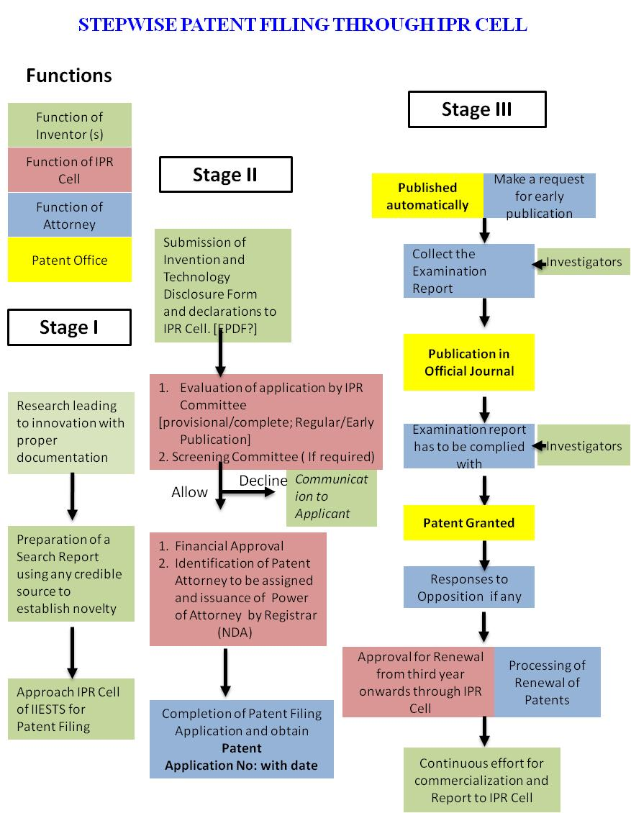

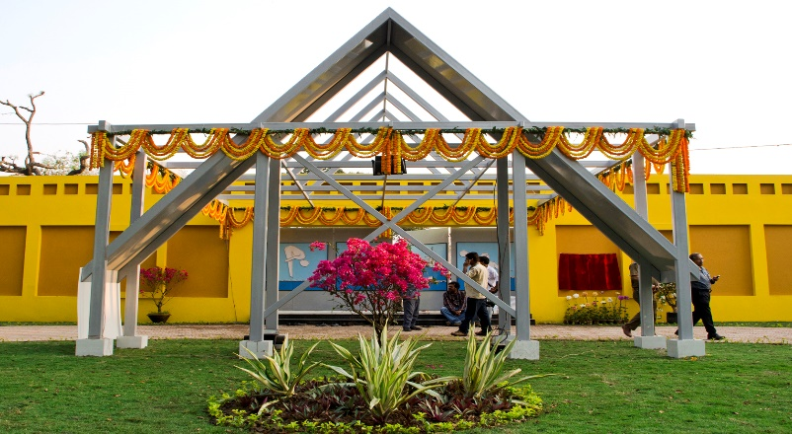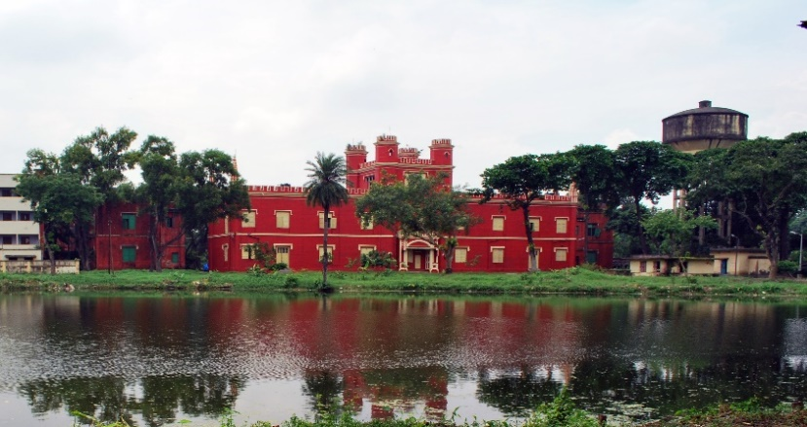**Heritage of IIEST, Shibpur**

**Slater Hall Swimming Pool**

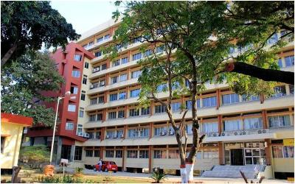

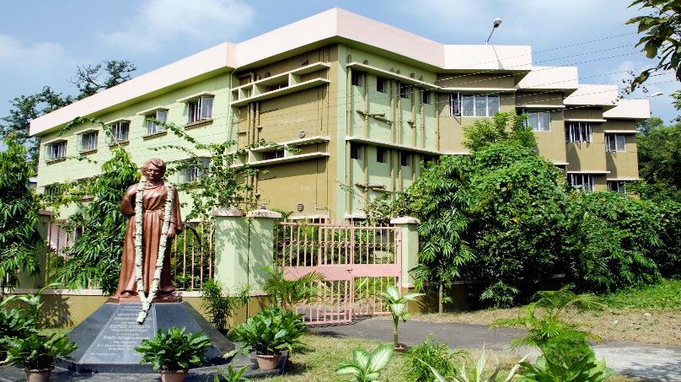

**Nivedita Ladies Hostel Science and Technology Building**

**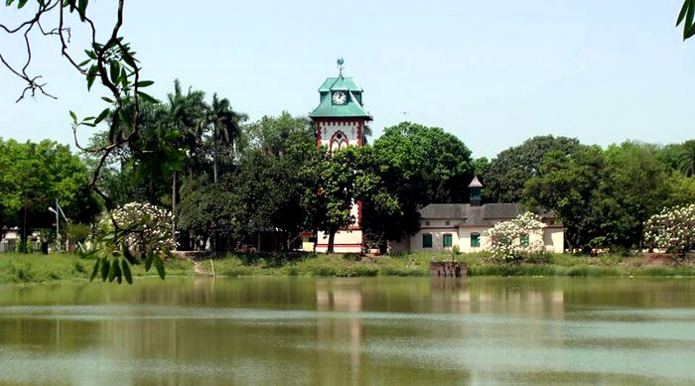**

**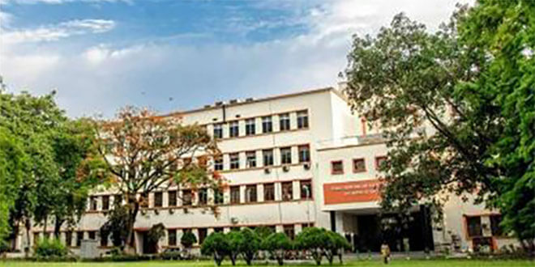**

**Academic Building Clock Tower Lake**