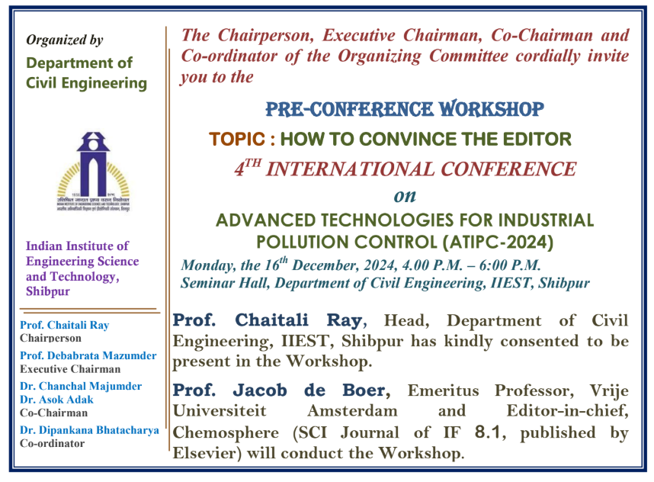

A pre-conference workshop in connection with the 4th International Conference on "Advanced Technologies for Industrial Pollution Control (ATIPC-2024)" was organized by the Department of Civil Engineering of IIEST Shibpur in hybrid mode on 16th December 2024. The workshop was conducted in person at the Seminar Hall of the Civil Engineering Department by Prof. Jacob de Boer, Emeritus Professor Vrije Universiteit Amsterdam and one of the Editor-in-chiefs of CHEMOSPHERE, a SCI journal published by Elsevier with Impact Factor 8.1. The workshop involved deliberations on " How to convince the Editor ", and was attended by faculty members, students, delegates and conference participants, and especially by research scholars. It was discussed in the course of the workshop that there is a growing need of good quality publications of scientific research from the scholars in internationally reputed journals. Indeed, the journals are now very much selective about the content and quality of any paper submission,1 and are mostly screening out the papers submitted to their portal in the light of orientation and outcome, even during Editor's primary evaluation. Since, authors are receiving a decision of rejection without any clarification, they are not in a position to know about their shortcomings. In view of that, the workshop participants were made aware about the expectations of various reputed journals from the editorial level, including framing of the abstract, showcasing the research highlights, facilitating proper data interpretation, adequate indexing of references, appropriate presentation of figures, tables and overall publication ethics while writing a journal paper. The workshop provided a truly enriching experience and was a major takeaway for all the research stakeholders, planning to publish their research work in high-quality journals.

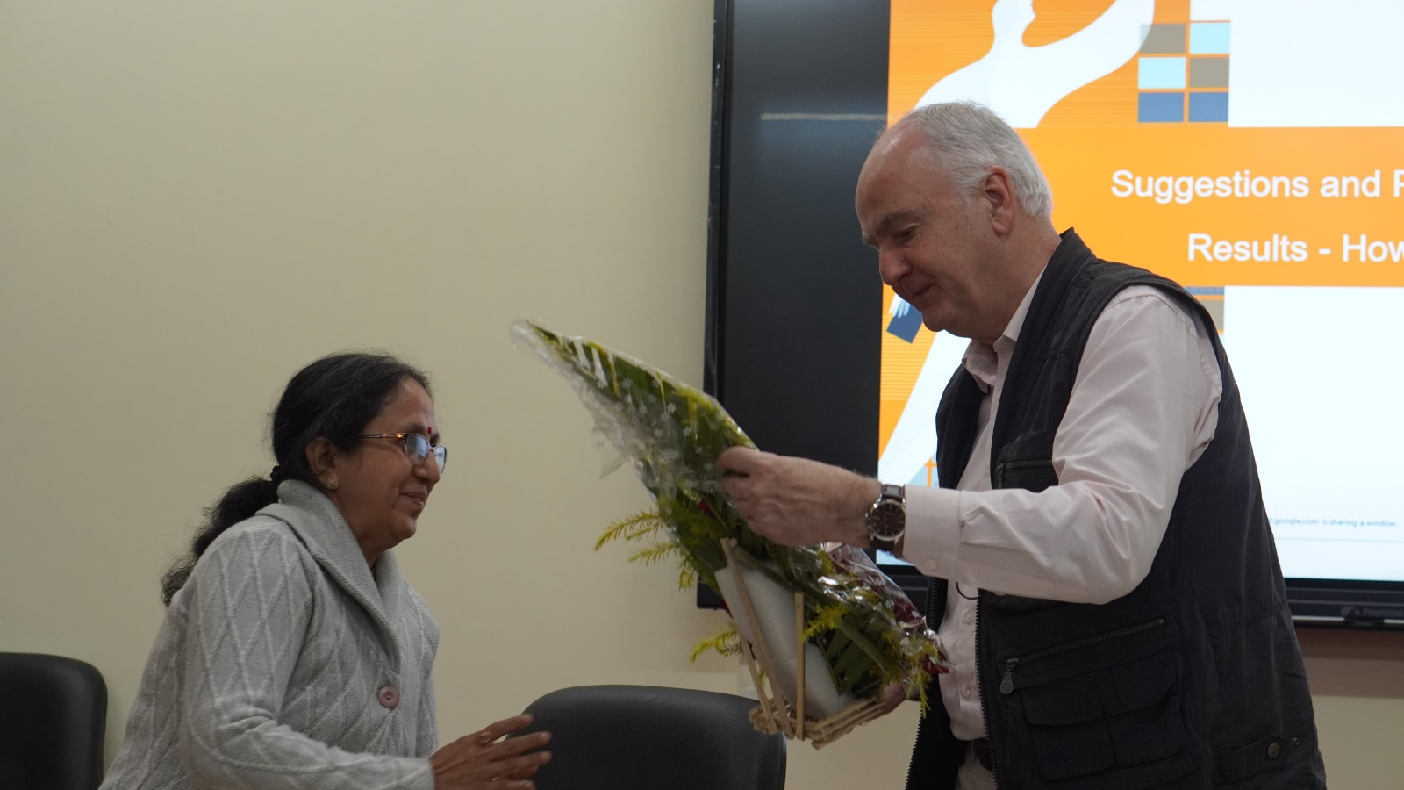

**Welcoming of Prof. Jacob de Boer by Head, Department of Civil Engineering, IIEST Shibpur**

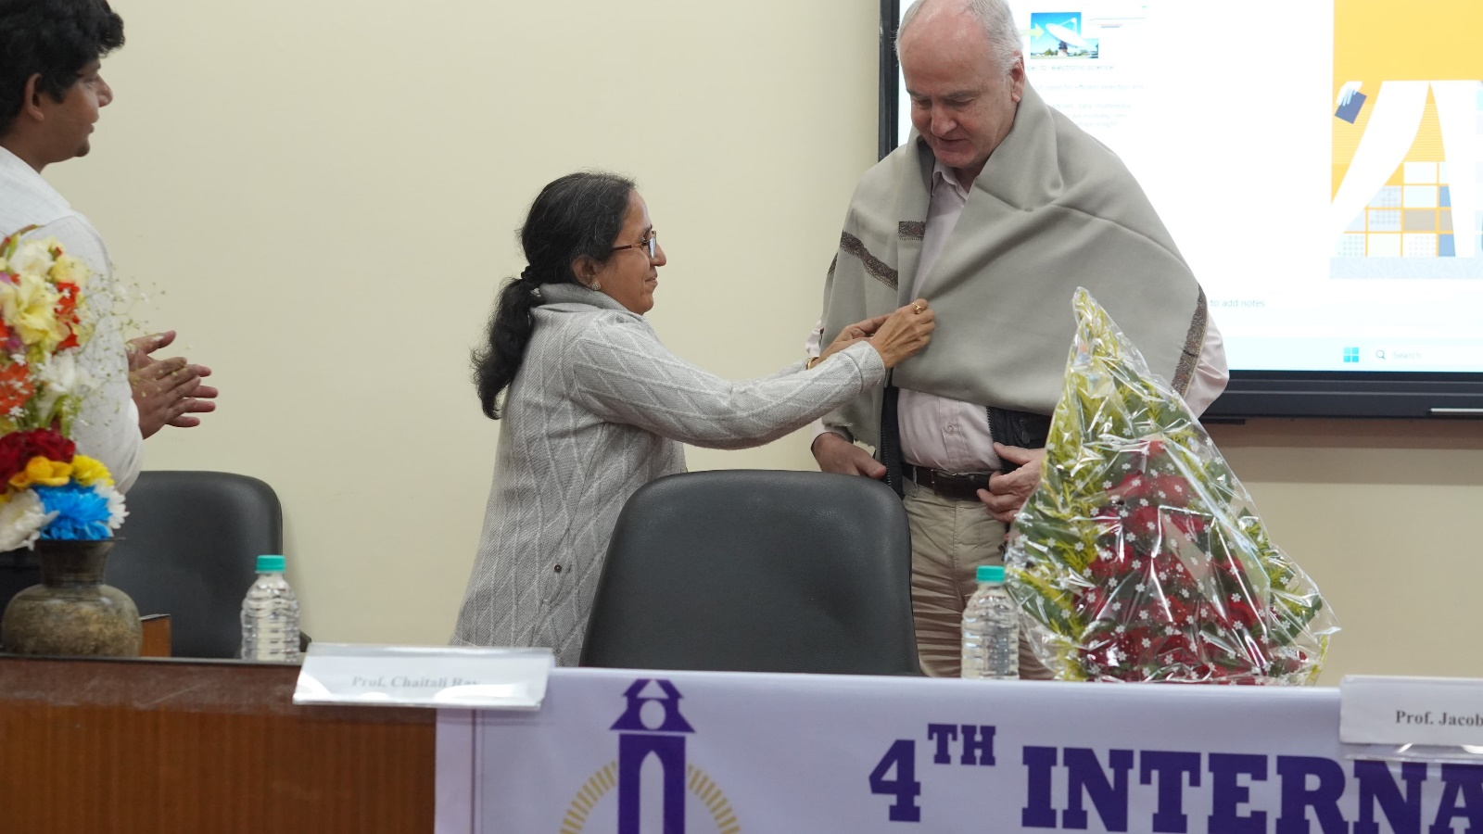

**Felicitation of Prof. Jacob de Boer by Head, Department of Civil Engineering, IIEST Shibpur**

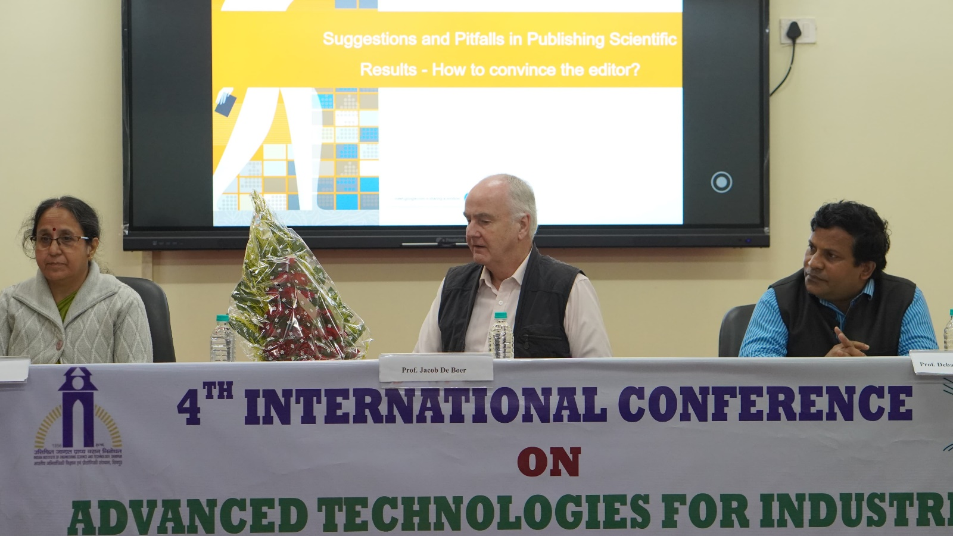

**Dignitaries gracing the dais during the pre-conference workshop**

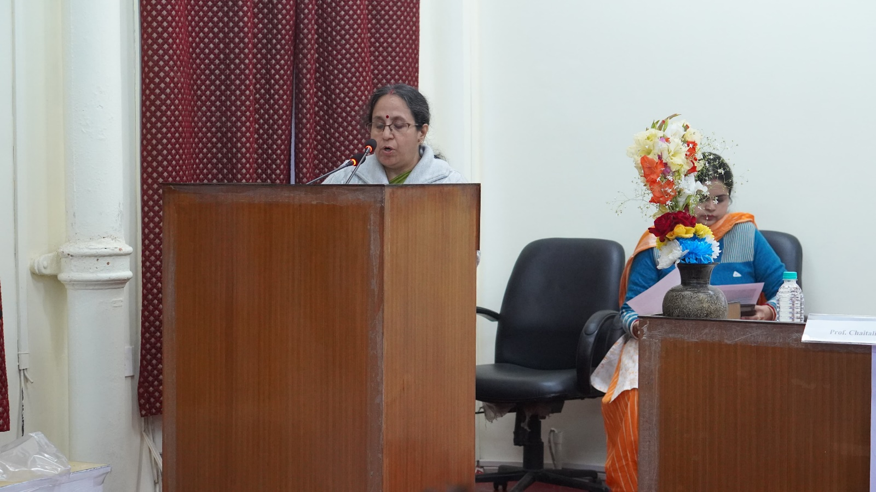

**Welcome address by Head, Department of Civil Engineering, IIEST Shibpur**

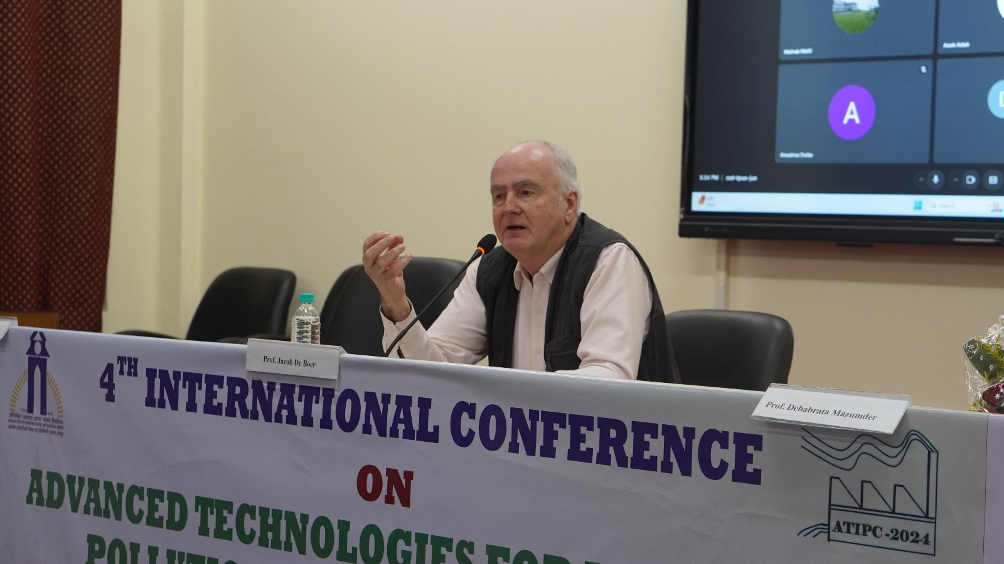

**Workshop being conducted by Prof. Jacob de Boer at the Civil Engineering Department**

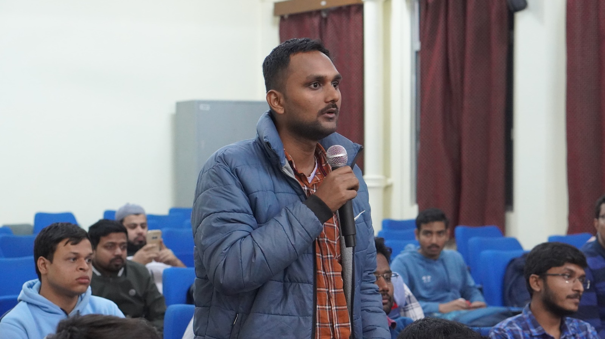

**Question-Answer Interactive session during the pre-conference workshop**